May 2022
Sunday | Monday | Tuesday | Wednesday | Thursday | Friday | Saturday
1 | 2 | 3 | 4 | 5 | 6 | 7
Brunch: Pancakes, Breakfast Pastry, Hash Brown & Bacon  Dinner: Sweet & Sour Chicken, Fried Rice & Mix Veg | Breakfast: Egg & Cheese Sandwiches  French Toast Sticks  Potato & Sausage  Lunch: Chicken Sandwiches w/Tater Tots  Dinner: Turkey Meatloaf w/Mashed Potato & Gravy | Breakfast: Waffles, Breakfast Wraps, Hash Brown and Bacon  Lunch: Enchiladas  Chips & Salsa  Dinner: Chicken Divan w/Rice Pilaf | Breakfast: Pancakes, Fried Eggs, Home Fries and Sausage  Lunch: General Tso’s Chicken w/Rice  Dinner: Spaghetti Bolognese, Salad & Garlic Bread | Breakfast: French Toast & Scrambled Eggs, Potato & Bacon  Lunch: Toasted Steak & Cheese Wraps w/ Seasoned Fries  Dinner: Smothered Chicken over Garlic Mashed Potato, Veg | Breakfast:  Egg & Cheese Quesadillas, Cinnamon Roll, Home Fries & Sausage  Lunch: Pizza & Fried Shrimp  Dinner: Roast Beef, Scalloped Potato, Veg & Warm Roll | Brunch: Cheese Omelets, French Toast Sticks, Hash Browns and Bacon  Dinner: Baked Chicken Parmesan w/Pasta & Veg
8 | 9 | 10 | 11 | 12 | 13 | 14
Brunch: Pancakes, Breakfast Sandwich, Sausage and Home Fries  Dinner: Meat Lasagna Sauteed Veg & Garlic Bread | Breakfast: Waffles, Fried Eggs, Bacon and Hash Browns  Lunch: Assorted Chicken Wraps & Potato Chips  Dinner: Chicken Broccoli Alfredo | Breakfast: French Toast, Scrambled Eggs, Potato & Sausage  Lunch: Chicken Quesadillas, Chips & Salsa  Dinner: PSA Picnic | Breakfast: Breakfast Burritos, French Toast Sticks, Hash Brown & Bacon  Lunch: Toasted Turkey Sliders w/Baked Mac & Chz  Dinner: Chicken Scallopini over Spaghetti, Mixed Veg | Breakfast: Waffles, Breakfast Pastry, Sausage  and Home Fries  Lunch: Sloppy Joe’s w/Onion Rings  Dinner: Million$ Chicken, Scalloped Potato & Veg | Breakfast: French Toast, Fried Eggs, Bacon and Hash Browns  Lunch: Pizza  Dinner: Burritos | Cold Breakfast/Brunch  Graduation Reception
15 | 16 | 17
Brunch: Scrambled Eggs, Waffles, Potato & Sausage  Dinner: Pasta w/meat Sauce & Bread | Brunch: TBD  Dinner: TBD | Brunch: TBD  Dinner: TBD |  | Monday-Friday  Salad Bar  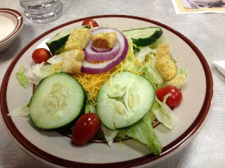 | Tues, Wed, Thurs  Pasta Bar  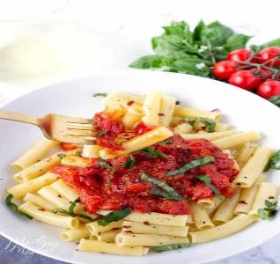
 | Have | A | Fantastic | Summer

